FAMILYCOURTPROCESS

ReferralFlowChart



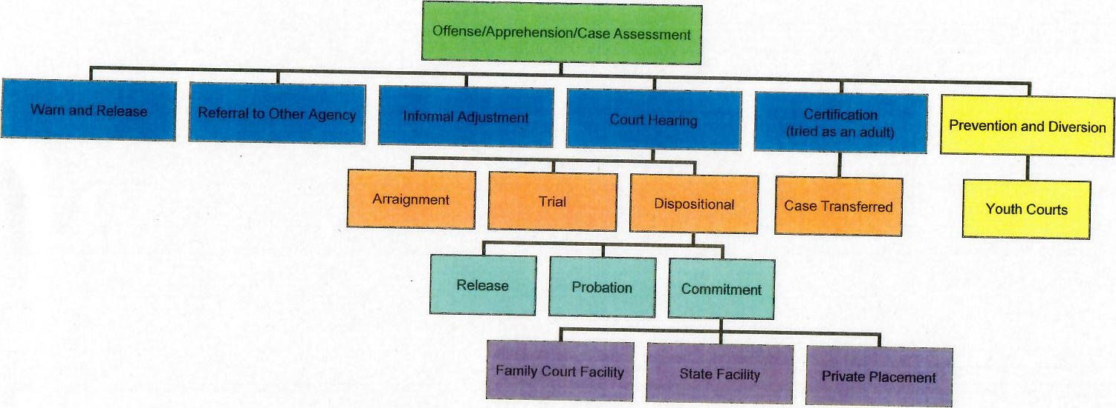

1丶96